Name _______________________________ Total Mark /30  
 (first) (last)

ID ______________

Date ____________

Lab Class ________

**Physics 101 Semester 1 2017**

**Formal Report No 1**

**Determining whether the energy of a cart rolling up and down an inclined plane is conserved.**

**Jaime Sequeira (42408823)**

23rd March 2014

Partners:

Rebecca Till

Janariah Keza

Farah Saal

Abstract

An experiment was conducted to find if the spring constant of a spring and to see if energy in a system of a track and cart on an inclined slope was conserved. The spring constant of the spring built into the cart was determined by using the equation F = -kx. The spring constant was calculated to be 593.2 ± 30.5 N $m^{-1}$ by compressing the spring to five different places and then using the F =-kx equation to find the constant. The conservation of energy theory was tested by launching a cart with the spring built into it up a slope and calculating the energy of the system at different points. 0.224 Joules of energy were lost between the start of the experiment (0.34 ± 0.03 Joules) and just before the first collision between the cart and the spring ($0.116 ±0.078 Joules$). This loss was due to the fact that non-conservative forces (drag and friction) acted on the cart and spring during the experiment. This experiment refuted the theory of energy conservation.

Introduction

It is impossible for energy to be created or just disappear [Patana, website]. Energy transforms from one form to the other. This includes kinetic energy, sound energy, heat energy, thermal energy. There are also potential energies such as gravitational potential, chemical potential and elastic potential. Therefore the initial energy of a system must be equal to the final energy of the system (Joules)

$$Efinal – Einital$$

must equal zero as there is no change regarding the energy of the system.

The kinetic energy of a moving particle can be calculated by using the formula

$$Ek = 1/2mv^{2}$$

where m is the mass of the object (kg) and v is the velocity of the object ($ms^{-1}$). Therefore the kinetic energy of an object is proportional to the mass and of the particle and the velocity squared of the particle.

The gravitational potential energy of a particle can be calculated by using the formula

$$Ep(g) = mgh$$

where m is the mass, g is the acceleration due to gravity ($9.81ms^{-2}$) and h is the height of the particle above the surface of the earth (metres).

The equation

$$F = -kx$$

displays the relationship between the restoring force (F) of a spring and the displacement (x) of the spring which is multiplied by the constant of the spring (k). The negative sign is used to show that the restoring force (F) acts in the opposite direction to the direction to the displacement. The elastic potential energy of a spring can be determined using the formula

$$U(e) = 1/2kx^{2}$$

Where k is the spring constant (N $m^{-1}$) and x is the displacement of the spring (metres)

This experiment was carried out in order to test if energy conservation applies when the cart rolls up and down the inclined slope. Therefore, it would be expected that the total energy of the system would be the same at any given point when applying the conservation of energy theory. Therefore the aim of this experiment was to determine the spring constant of a spring and to verify whether or not the energy in the system of a cart rolling up and down an incline was conserved, converted or lost.

Method

Cart with built in spring

Logger Pro Motion Detector

Logger Pro Force Sensor

Track with ruler built in

**Figure 1: Set up for the experiment for determining the spring constant and finding the energy of the system at different points.**

The equipment was set up as can be seen in Figure 1. The force sensor was zeroed by using the software built into the graphing program used for the recording of data (Logger Pro). When only the spring of the cart was touching the force meter, it was zeroed. The force sensor was calibrated so it would measure a positive force when anything was pressed against it. This meant that the sensor read zero at the starting position of the cart with the spring compressed. The displacement sensor was zeroed by compressing the spring of the cart and then zeroing the sensor. The sensor was calibrated to measure a positive displacement.

To find the spring constant, the cart was pushed toward the force sensor. This compressed the spring. The spring was compressed to 5 different distances outlined in the results section of this report.

The angle of the track was calculated using trigonometry. The hypotenuse was determined by finding the distance between any two points on the ruler built into the track. The vertical height was calculated by finding the difference in the vertical heights of these two points using a metre ruler.

With the angle calculated, the experiment was conducted to find the energy of the system at different times. The Logger Pro software was loaded. The collect data button was pressed to initiate the experiment data log. With the spring compressed and the cart sitting on the track touching the force sensor, a ruler was used to tap the hump on the top of the cart. The spring was released by this motion and the cart started to move up the track and then back down. This continued until the cart came to a rest. The results from Logger Pro provided the data needed for this report.

Results

|  |  |
| --- | --- |
| $$x ± 0.50 × {10}^{-3}(metres)$$ | $$F ± 0.005 (N)$$ |
| 0.010 | 5.700 |
| 0.015 | 9.400 |
| 0.020 | 12.100 |
| 0.025 | 14.900 |
| 0.030 | 17.000 |

**Table 1: Measured displacement of the cart (x) and the resultant force measured by the force sensor (F).**

The uncertainties for all the heights and distances were chosen due to half the scale of the one metre ruler being one half of a millimetre.

Measurements for finding the angle of the track

Hypotenuse = 101.83 cm = 1.0200 ± 0.0005 metres

Height at point 1 = 7.8 cm = 0.0780 ± 0.0005 metres

Height at point 2 = 2.5 cm = 0.0250 ± 0.0005 metres

Cart Mass

The mass of the cart was determined to be 0.512 ± 0.005 kg. The uncertainty was estimated by halving the scale adopted by scales that were used determine the mass.

Analysis

Finding the spring constant

The equation relating the restoring force and the spring constant is

$$F = -kx$$

Therefore in order to calculate the spring constant

$$k = F/x$$

The spring constant was calculated for every displacement.

$$Displacement 1: k = 5.70/0.010 = 570 Nm^{-1}$$

$$Displacement 2: k = 9.40/0.015 = 628 Nm^{-1}$$

$$Displacement 3: k = 12.1/0.020 = 605 Nm^{-1}$$

$$Displacement 4: k = 14.9/0.025 = 596 Nm^{-1}$$

$$Displacement 5: k = 17.0/0.030 = 567 Nm^{-1}1$$

The mean of these values was calculated in order to find the mean spring constant.

$Therefore: k =\frac{\left(570 + 628 + 605 + 596 + 567\right)}{5}$

$$k = 593 Nm^{-1}$$

Uncertainties

The uncertainties were obtained by using half the range of the data.

$$δk =\frac{\left(628 – 567\right)}{2}$$

$$δk = ± 30.5$$

$$Therefore: k = 593.2 ± 30.5 Nm^{-1}$$

Calculating angle of the incline:

Trigonometry was used to calculate the angle of the track. The value of the hypotenuse was found by finding the difference the length between two points on the ruler attached to the track. The vertical height was measured by finding the difference of the vertical height of the two points.

$$\sin{θ}=\frac{opposite}{hypotenuse}$$

$$θ= \sin^{-1}{(\frac{0.053}{1.02})}$$

$$θ=2.98°$$

Uncertainties

$$\%δ hypotenuse = \frac{0.0005 m}{1.02 m} = 0.049\%$$

$$\%δ opposite = \frac{0.0005 m}{0.053 m }= 0.94\%$$

$$\%δ (\frac{opposite}{hypotenuse}) = 0.049\% + 0.94\% = 0.989\%$$

$$Using the brute force method:$$

$$θ max=\sin^{-1}(({\frac{opposite}{hypotenuse }})+\%δ) –\sin^{-1}{(\frac{opposite}{hypotenuse}}) )$$

$$θ=\sin^{-1}\left(\left(\frac{0.053}{1.01}\right)+0.989\%\right)-\sin^{-1}{( \frac{0.053 }{1.01})}$$

$$θ=\sin^{-1}\left(\left(\frac{0.053}{1.01}\right)+0.0529\right)-\sin^{-1}{(\frac{0.053}{1.01})}$$

$$θ=\sin^{-1}\left(0.1054\right)-\sin^{-1}{(}0.0525)$$

$Therefore Maximum θ= 3.04$ °

$$Uncertainty = 3.04 – 2.98$$

$$Therefore the angle of the track was 2.98 ± 0.06°$$

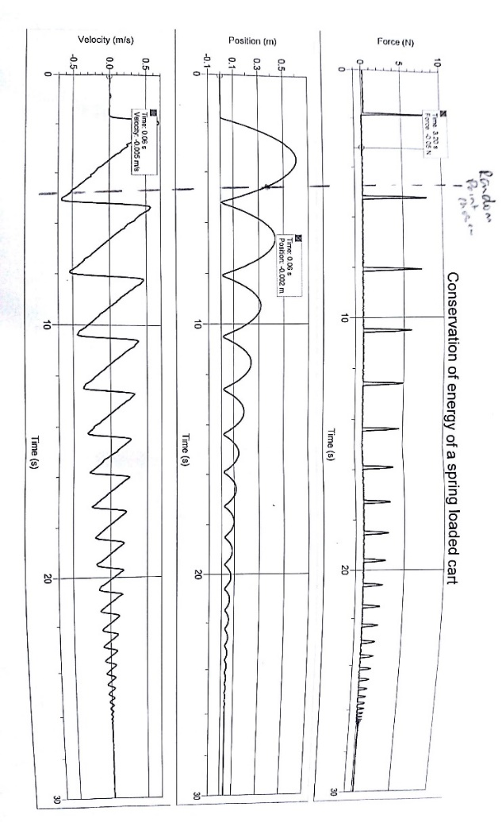

The software, Logger Pro, used the force sensor and displacement sensor to record the results during the experiment. The graph below shows the data collected by Logger Pro and the specific data points required by the Physics Laboratory Manual [Franklin, Clifford, Phys101 Lab Manual] were plotted in the table below the graph.

**Figure 1: The results obtained using Logger Pro in order to calculate the energy of the system at different points.**

|  |  |  |
| --- | --- | --- |
| Quantity | Value | Units |
| Initial compression of spring (distance from neutral position) | 0.034 | metres |
| Maximum compression of the spring during the collision | 0.027 | Metres |
| Velocity of cart just after leaving the spring | 0.601 | Metres per second |
| Velocity just before the collision | -0.648 | Metres per second |
| Maximum distance travelled up the incline | 0.66 | Metres |
| Position of randomly selected point | 0.391 | Metres |
| Velocity of randomly selected point | -0.416 | Metres per second |
| Mass of the cart | 0.512 | Kilograms |

**Table 2: Recorded data for various situations during the experiment using the graphs created by Logger Pro**

Energy calculations

1. The energy at the start of the experiment was all stored inside the spring in the form of elastic potential energy. This amount of energy was calculated using the equation

$$Ep(spring) = ½ kx^{2}$$

$$Ep(spring) = ½ 593.2 × {0.034}^{2}$$

$$Ep(spring) = 0.343 Joules$$

Uncertainty

$$\%δ k =\frac{30.5}{593.2} × 100 = 5.14\%$$

$$\%δ x^{2} =((\frac{0.0005}{0.034 })× 100)) × 2 = 2.94\%$$

$$2.94 + 5.14 = 8.05\%$$

$$Therefore: δ ½ kx^{2} =\frac{8.05}{100} * 0.343$$

$$δEp = ±0.028 Joules$$

Therefore the amount of energy in the system at the start of the experiment was

0.34 ± 0.03 Joules

1. Just after the cart lost contact with the spring, the elastic potential energy of the fully released spring was converted into both kinetic energy and gravitational energy.

$$E\left(Total\right)=E\left(kinetic\right)+Ep\left(Gravitational\right)$$

$$E\left(total\right)=\frac{1}{2}mv^{2}+mgΔh$$

$$E\left(total\right)=\frac{1}{2}×0.512 ×{0.68}^{2}+0.512×9.818.837×{10}^{-4}$$

$$E\left(Total\right)=0.122 ±3.7\% \left(Using method that was used before for uncertainty\right)$$

$$E\left(total\right)=0.122 ±0.005 Joules$$

This did not agree with the theory of conservation of energy because even after taking the extremes of the uncertainties, the energy calculated of the system at this point was not the same as what was calculated as the starting energy of the system.

1. The point when there was maximum gravitational potential energy of the system was at the top of the track i.e. just before the cart started to roll back down.

$$ΔEp(gravitational) = mgΔh$$

$$Δh was determined using trigonometry$$

$$sin\left(2.98\right)= \frac{opposite}{0.606}$$

$$opposite (the change in vertical height) = 0.0315 metres$$

$$Therefore ΔEp (gravitational) = 0.512 × 9.81 × 0.0315$$

$$ΔEp (Gravitational) = 0.158 Joules$$

Uncertainty

$$\%δm = (\frac{0.005}{0.5124}) ×100 = ± 0.976\%$$

$$\%δh used the method that was used for calculating the angle = ± 15.87\%$$

$$\%δ Total = ± 18.86\%$$

Therefore the energy of the cart when it reaches the top of the slop was 0.16 ± 0.03 Joules.

This refuted the theory of energy conservation as after taking the uncertainties into account, the energy of the system at the start was still larger than the energy of the system at this point.

1. Just before the cart collided with the force sensor for the first time, the total energy in the system was the sum of the kinetic energy and the gravitational potential energy of the system at that point.

$$E\left(Total\right)=\frac{1}{2}mv^{2}+mgΔh$$

$$E\left(Total\right)=\frac{1}{2}×0.512×{0.648}^{2}+0.512×9.81×{1.78110}^{-3}$$

$$E\left(Total\right)=0.116 ±0.078 Joules (Uncertainty obtained with previous methods)$$

This did not agree with the theory of energy conservation as when the uncertainties were taken into account, the energy of the system at this point was not equal to the energy of the system at the start of the experiment.

1. When the compression of the spring was at the maximum during the collision, the energy of the system was calculated using the maximum spring compression at this point:

$$Ep(spring) = ½ kx^{2}$$

$$Ep(spring) = ½ 593.2 × {0.027}^{2}$$

$$Ep(spring) = 0.216 Joules$$

Uncertainty

$$\%δ k = 5.14\% as per the equation in the example before.$$

$$\%δ x^2 = (\frac{0.0005}{0.027} × 100) × 2 = 3.70\%$$

$$\%δ ½ kx^{2} = 8.84\%$$

$$δEp = \left(\frac{8.84}{100}\right) × 0.216 = ± 0.019$$

Therefore the maximum elastic potential energy stored inside the spring during the collision of the cart with the force metre was calculated to be

0.22 ± 0.02 Joules

This result refuted the theory of energy conservation again in this experiment because when the uncertainty was taken into account, the energy of the system at this point was not equal to the energy of the system at the start.

Discussion

In the first experiment, the spring constant of the spring in the cart was determined to be 593.2 ± 30.5 $Nm^{-1}$. This was a small uncertainty due to the technique used to determine the spring constant. Since the Logger Pro software was used, it decreased the uncertainty of the force since it was calculated by a sensor. It removed any form of parallax. In order to decrease the uncertainty even further, a digital Vernier calliper could have been used to measure the displacement of the cart which would again remove the uncertainty due to parallax.

In the second experiment, the initial energy of the system was calculated to be 0.34 ± 0.03 Joules. The energy just after the spring was fully released was $0.122 ±0.005 Joules$. When the cart reached the maximum height, the energy of the system was 0.16 ± 0.03 Joules. Just before the first collision, the energy of the system was $0.116 ±0.078$ Joules. The energy of the system at the last point, when the spring was compressed to the maximum, was 0.22 ± 0.02 Joules. The energies at points two and 5 were not consistent with the rest of the data. The calculated energies of the system refuted the theory that energy was conserved in this experiment. For the energy to have been conserved, only conservative forces would have acted on the system. However, the energy of the system decreased after the spring was released and it continued to decrease for the duration of the experiment. This was due to the non-conservative forces, friction and drag, acting on the system [Physics Classroom, website]. These force converted some of the energy in the system into heat energy and sound energy and dissipated it. The system was not able to use that energy and the total energy of the system decreased from 0.34 Joules to 0.116 Joules (ignoring calculation for point two). Energy was not conserved in this experiment.

A good real life example of when energy conservation actually occurs is to think of lake reaching a waterfall. As can be seen from Table 3 below, as the lake reaches a waterfall, the energy of that water changes throughout the fall as the water transforms its initial energy into other forms of energy.

|  |  |  |  |
| --- | --- | --- | --- |
| Position | E(potential) | E(kinetic) | E(thermal) |
| Lake above falls | xxxxxx | - | - |
| At the top of falls | xxxxx | x | - |
| Halfway down the falls | xxx | xxx | - |
| At the bottom of the falls before impact | x | xxxxx | - |
| Just after impact | x | - | xxxxx |
| As it flows into the sea | - | x | xxxxx |

At the top of the falls, there was only gravitational potential energy acting on the water. As the water starts to drop from the top of the waterfall, the water gains speed by converting some of the potential energy into kinetic energy. At the end of the fall, the kinetic energy was turned into thermal energy and the water became warmer.

For example, how high would the waterfall have to be for the water to be heated by one degree? Using the equations $Ep = mgh and E\left(thermal\right)= mcΔT$

$$where c of the water=4200Jkg^{-1}K^{-1}$$

$$The mass cancels out leaving$$

$$gh = cΔT$$

$$rearranging gives h =\frac{cΔT}{g}$$

$$h = 4,200 × \frac{1}{9.81} = 428m$$

Conclusions

The aim of this experiment was to determine the spring constant of a spring and to verify whether or not the energy in the system of a cart rolling up and down an incline was conserved, converted or lost. The constant of the spring (k) was calculated to be 593.2 ± 30.5 N $m^{-1}$. The energy of the system at the five selected points of the experiment were 0.34 ± 0.03 Joules, $0.122 ±0.005 Joules$, 0.16 ± 0.03 Joules, $0.116 ±0.078 Joules$ and 0.22 ± 0.02 Joules respectively. The change in the energy of the system was determined to be a loss of 0.224 Joules after ignoring the last energy calculation. This was due to the fact that non-conservative forces (friction and drag) acted on the cart and transformed the 0.224 Joules of energy into heat and sound energy. Energy was not conserved in this experiment. The results obtained for both experiments were consistent apart from the energy of the system at points two and five which were higher than they should have been.

References

Patana.ac.th, Precision and Accuracy, accessed from: <https://www.patana.ac.th/secondary/science/anrophysics/ntopic1/resources/accuracy%20and%20precision.htm>, accessed on 3/04/2017

Franklin, Clifford, Phys101S1 Lab Manual 2017, Engineering Physics A: Mechanics, Waves, Electromagnetism and Thermal Physics, Department of Physics and Astronomy, University of Canterbury

Physics Classroom, website, <http://www.physicsclassroom.com/mmedia/energy/ie.cfm>, accessed on 6/04/2017